Exercise 7: Financial Forecasting – Analysis

Implementation:
Forecast.java:
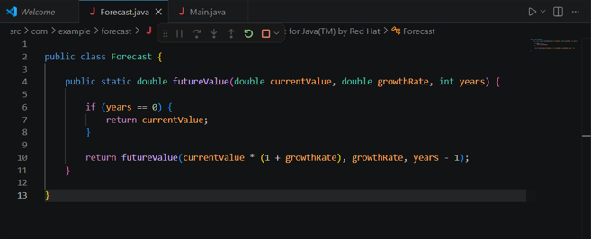

Main.java:
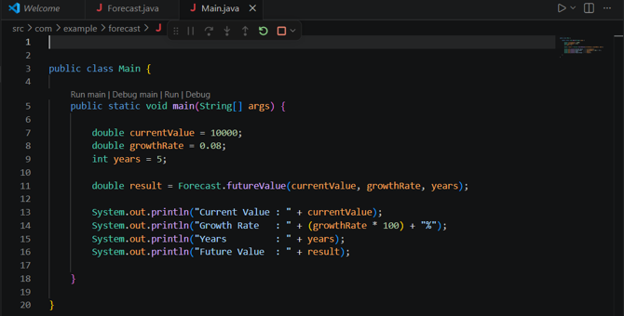

Output:
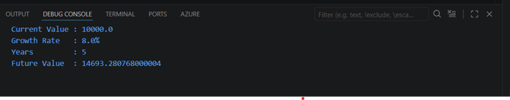

1. Understanding Recursive Algorithms:
Recursion is a programming technique in which a method calls itself to solve a problem. Each recursive call works on a smaller version of the original problem until a stopping condition (base case) is reached. Recursion helps make problems involving repeated calculations simpler and easier to understand.

2. Recursive Approach Used:
The program predicts the future value of an investment using recursion. For each recursive call, the current value is increased by the growth rate and the number of years is reduced by one. When the number of years becomes zero, the current value is returned as the final future value.
Formula Used:
Future Value = Current Value × (1 + Growth Rate)

3. Time Complexity Analysis:
Case | Time Complexity
Best Case (years = 0) | O(1)
Average Case | O(n)
Worst Case | O(n)
Here, n represents the number of years. The recursive method performs one function call for each year.

4. Optimization of the Recursive Solution:
A simple recursive solution creates one function call for every year, which increases memory usage due to the call stack. The solution can be optimized by:
• Using an iterative (loop-based) approach.
• Using memoization when repeated recursive calculations are required.
These techniques reduce unnecessary computation and improve performance.

